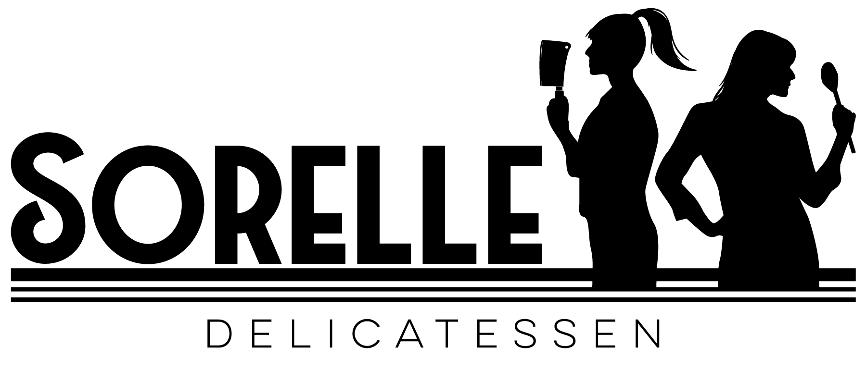 CALL IN ORDERS: 719-395-8417

SANDWICHES SERVED WITH MAYO, TOMATO, ONION, SHREDDED LETTUCE & HOUSE DRESSING
Soft baguette Sizes: Full (9in) or Half (4.5in) - Gluten Free bread available for $3/full $1.5/half
Also available: Sourdough Bread, Rye Bread & Whole Wheat Wrap

The Sorelle Italian - H $7.99 F $13.99
All Natural Genoa Salami, Capicola, Ham & Provolone - Served on Baguette

The Turkey Havarti - H $7.99 F $13.49 - Add Bacon! $2.50
All Natural Oven Roasted Turkey Breast, Havarti Cheese, Sundried Tomato Pesto Mayo - Served on Baguette

The Turkey Swiss H $7.99 F $13.99
All Natural Oven Roasted Turkey, Prosciutto, Swiss Cheese, Roasted Red Bells - Served on Baguette

The Ham & Smoked Cheddar H $7.99 F $13.49
All Natural Smoked Ham, Smoked Cheddar Cheese - Served on Baguette

The Roast Beef Horseradish H $7.99 F $13.99
All Natural Angus Beef, Sharp Cheddar Cheese & Creamy Horseradish Sauce - Served on Baguette

The Hummus - H $7.99 F $13.49 Can Be Vegan, Just Ask!
House Made Red Pepper Hummus, Cucumber, Roasted Red Bells, Sharp Cheddar, Arugula - Served on Baguette

The Turkey, Bacon, Avocado H $7.99 F $13.99
All Natural Oven Roasted Turkey, Bacon & Avocado Spread - Served on Baguette

The Pesto Chicken H$7.99 F$13.49
All Natural Oven Roasted Chicken, House-Made Spinach Walnut Pesto & Provolone - Served on Baguette

The Ham & Pineapple H $7.99 F$13.49
All Natural Applewood Smoked Ham, Pineapple & Crispy Jalapenos - Served on Baguette

The Chicken Gouda H $7.99 F $13.49
All Natural Oven Roasted Chicken, Roasted Red Pepper Garlic Sauce & Smoked Gouda Cheese - Served on Baguette

The Green Chile Chicken H$7.99 F$13.99
All Natural Oven Roasted Chicken & Roasted Green Chile Cream Cheese - Served on Baguette

Specialty Sandwiches - Served as Listed

The Caprese - H $7.99 F $13.49
Fresh Mozzarella, Basil, Tomatoes, Balsamic Reduction & EVOO - Served on Baguette
Add Prosciutto $3!

The Turkey Cranberry H $7.99 Full $13.49
All Natural Oven Roasted Turkey, Cranberry Sauce, Arugula & Cream Cheese - Served on Baguette

Nana’s Meatballs Half $7.99 Full $13.99
Certified Angus Ground Beef and Pork Meatballs, Red Sauce, Fresh Mozzarella & Parmesan – Served Toasted on Baguette

The Roasted Veggie Half $7.99 Full $13.49 - Can be Vegan, Just Ask!
Roasted Assorted Veggies, Fresh Mozzarella, Dried Apricot, Harvest Greens, Onion, Roasted Red Pepper Sauce & House Dressing – Served Toasted on Baguette

The Hot Beef Full Only $13.99
All Natural Angus Beef Finished in House Made Au Jus, Provolone & Spicy Giardiniera - Served Toasted on Baguette

Uncle Frank’s Porchetta H $7.99 F $13.99
House-Made Porchetta, Roasted Red Pepper Garlic Sauce, Caramelized Onions & Arugula - Served Toasted on Baguette

The Reuben H $7.99 F $13.49
All Natural Pastrami, Swiss, Sauerkraut & House Made Thousand Island Dressing – Served Toasted on Rye Bread

The Classic BLT H$7.99 F$13.49 -add Avocado Spread! $1.50
All Natural Bacon, Lettuce, Tomato, Mayo & House Dressing - Served on Baguette

Chicken Salad Sandwich H $7.99 F $13.49 - Or Make it a Salad!
Diced chicken mixed with cranberries, toasted walnuts, celery & mayo, served with tomatoes, onions & harvest greens, topped with House Dressing - Served on Baguette

The Smoked Brisket Full Only $13.99
Certified Angus Smoked Brisket, Caramelized Onions, Smoked Cheddar & Spicy Brown Mustard - Toasted on Baguette

Avocado Toast $9.99 Can Be Vegan, Just Ask!
Avocado Spread, Cucumber, Tomato, Onion & Everything Seasoning - Served on 2 slices of Toasted Baguette

SALADS

Caesar - Side $6.99 Full $11.99
Romaine & Parmesan Tossed in Caesar Dressing & Topped with House-Made Croutons

Sorelle House - Side $6.99 Full $11.99
Harvest Mixed Greens, Cucumbers, Tomatoes, Parmesan & Carrots Topped with Choice of House Vinaigrette or House Ranch

Caprese - Side $6.99 Full $11.99
Romaine, Fresh Mozzarella, Heirloom Tomatoes & Basil topped with Olive Oil & Balsamic Glaze

Antipasto Salad - Side 7.99 Full $13.49
Romaine, Selection of Italian Meats & Cheese with Pepperoncini, Tomatoes, Cucumbers, Onions & Roasted Red Peppers Topped with House Vinaigrette

Apple Cranberry Salad - Side 7.99 Full $13.49
Harvest Mixed Greens, Apples, Feta, Dried Cranberries, Bacon & Almonds Topped with House Made Poppyseed Dressing

Ahi Tuna Salad - Full Only $17.99
Harvest Mixed Greens, Seared Ahi Tuna, Toasted Almonds, Dried Apricots, Onions, Carrots & Wonton Strips Topped with House Made Citrus Ginger Vinaigrette

ADD Chicken Breast to any salad - $6

SOUP
Daily Selection of House-Made Soup Served w/Bread or Crackers
Cup $5.99 Bowl $8.99
PASTA

Half $7.99 Full $13.49

Daily pasta shape served with your choice of house made sauce topped with Parmesan:

Red Sauce
Alfredo
Bolognese + Half $2 Full $4

Classic House Made Lasagna - $13.99

Fresh House Made Pasta, Ricotta, Mozzarella, Fresh Basil & Red Sauce - + Bolognese for $4!

Add any of the Following Meats to your Lasagna or Pasta:
Meatballs - $2.50 per ball
Chicken breast - $6

For the Littles (12 & under) - $8.99
includes small drink or apple juice & choice of chips or applesauce

Half Sandwich: ham or turkey and cheese on baguette with choice of toppings
Peanut Butter & Jelly - served on baguette with seasonal Jelly
Small order of pasta with Alfredo, Butter or Red Sauce topped with Parmesan cheese

Looking for something quick and easy for dinner? Try our Take and Bake Options! House Made Lasagna, Ravioli & more!!

*consuming raw or undercooked items may increase your chance of foodborne illness
*While we will strive to accommodate requests for special meals for customers who have food allergies or intolerances, we cannot guarantee completely allergy-free meals. This is due to the potential of trace allergens in the working environment and supplied ingredients.

